TASK # 01:
Develop a utility that finds out whether a particular day is a public holiday or not? Take the month and day from the user.
Flow Chart : 5 minutes Coding : 10 minutes

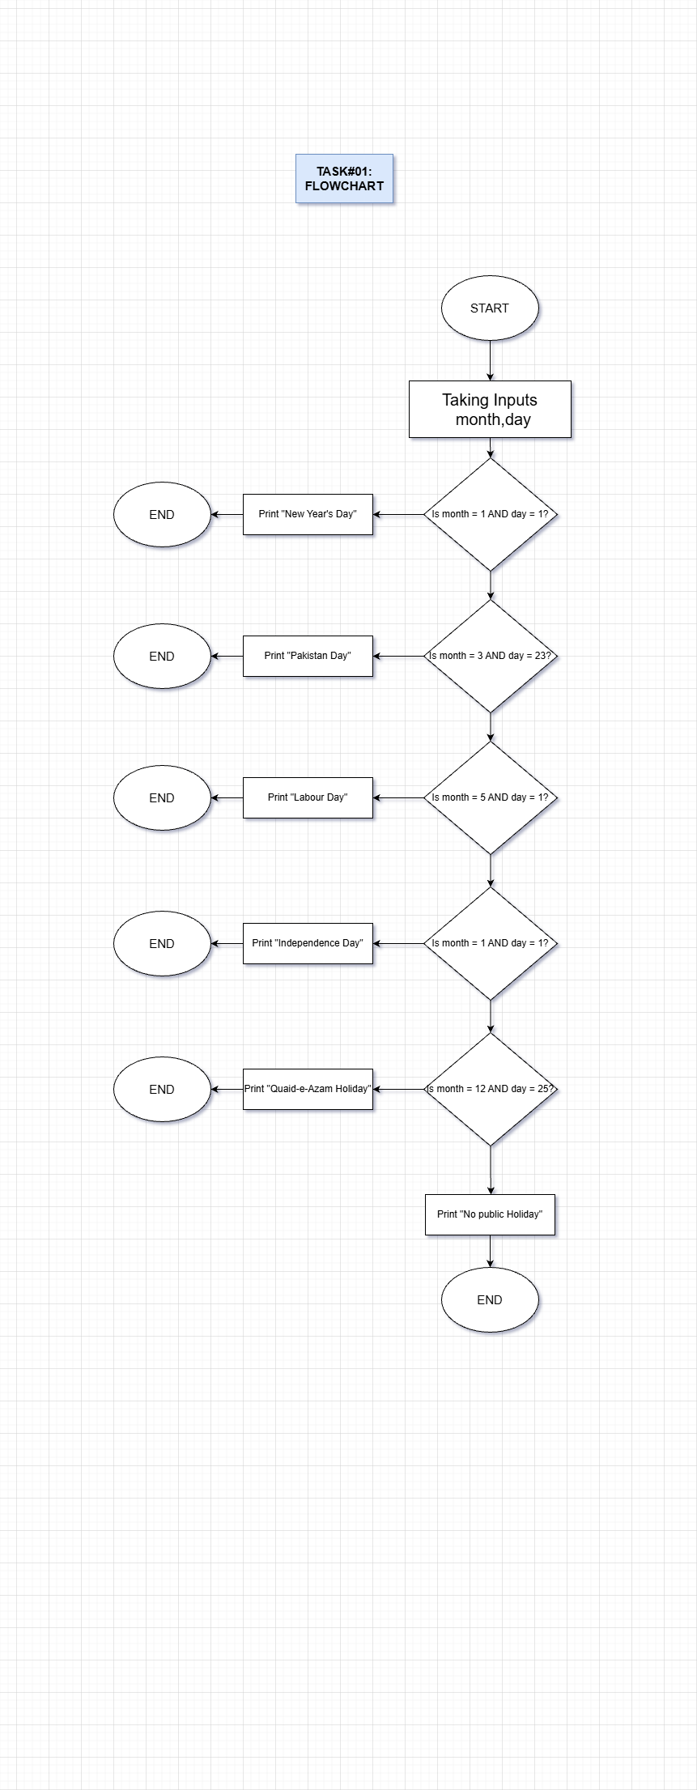

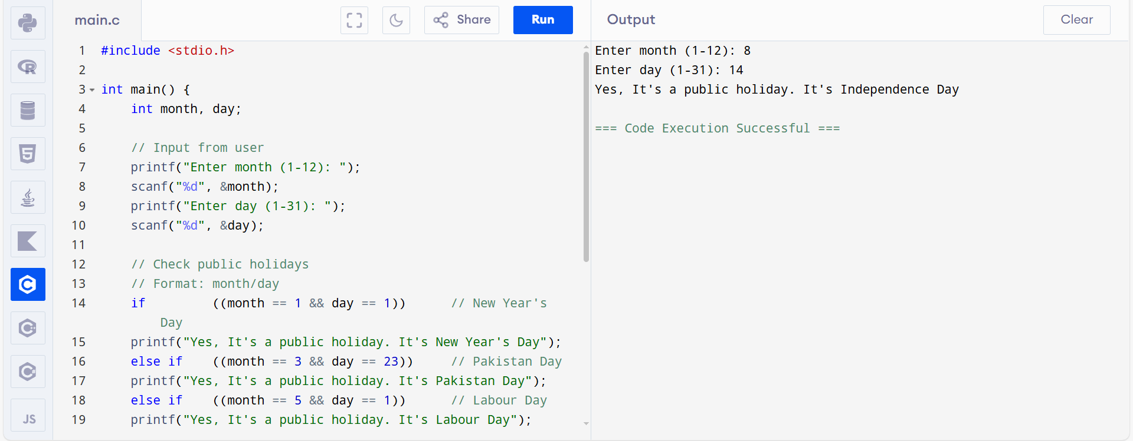

TASK # 02:
Find out whether a particular year is a leap year or not? Consider some authentic source for figuring out leap year such as NASA.
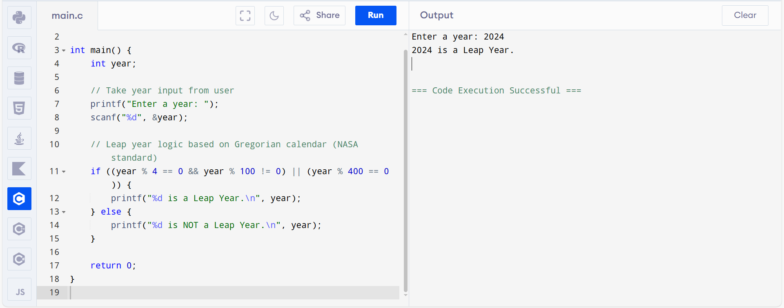
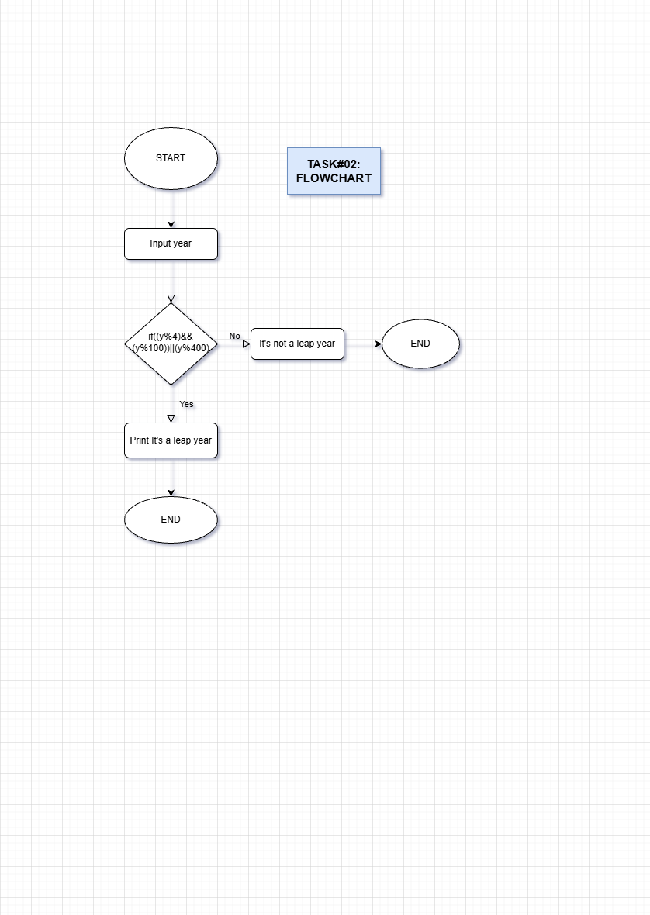
Flow Chart : 10 minutes Coding : 10 minutes

TASK # 03:
Take latitude and longitude in degree minute and seconds and convert it into decimal form. Figure out whether it is above the equator or not?
Flow Chart : 15 minutes Coding : 15 minutes
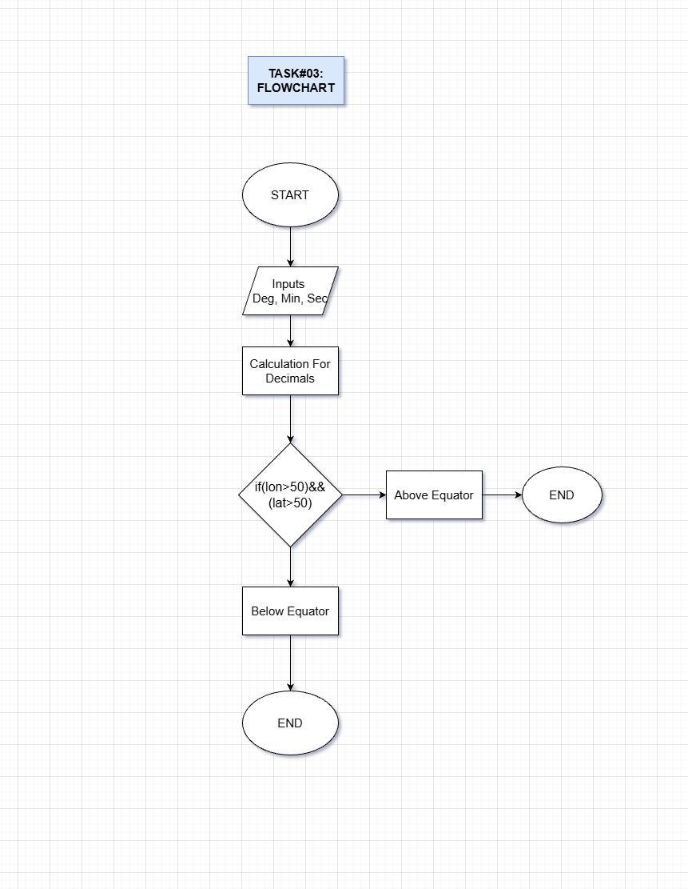

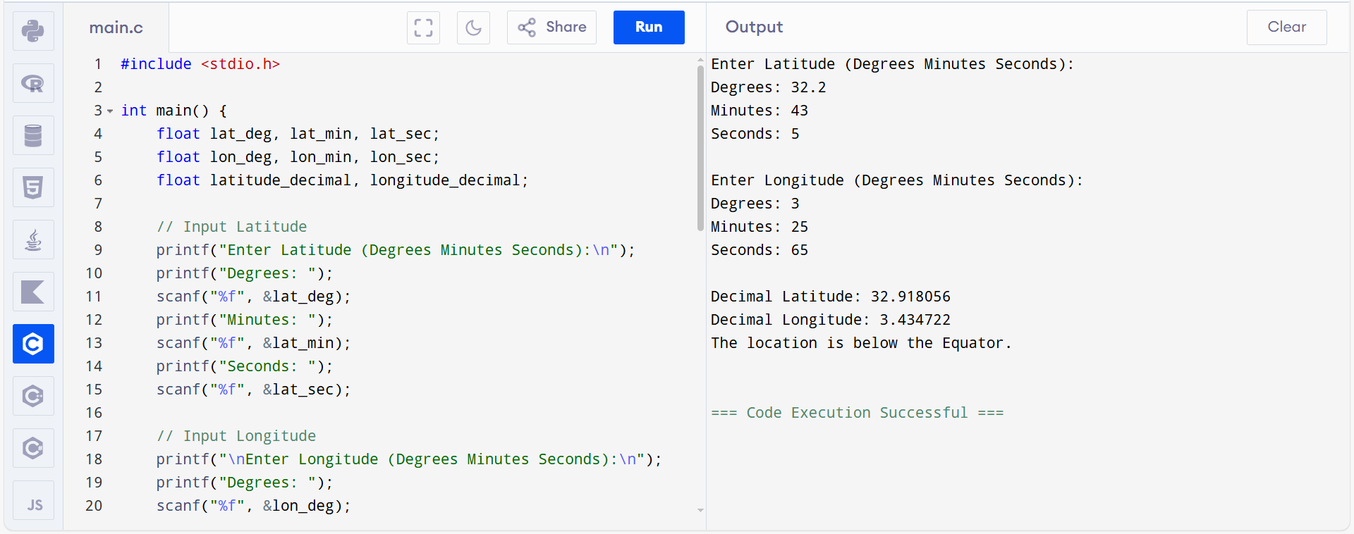
TASK # 04:
Take a 3-digit number from the user and print out the digit at unit, 10th and 100th place.
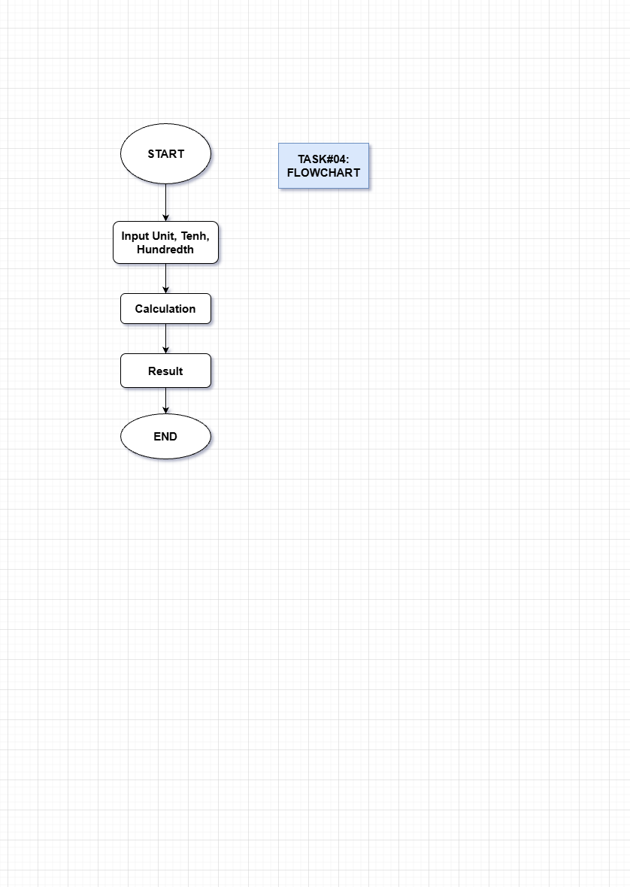

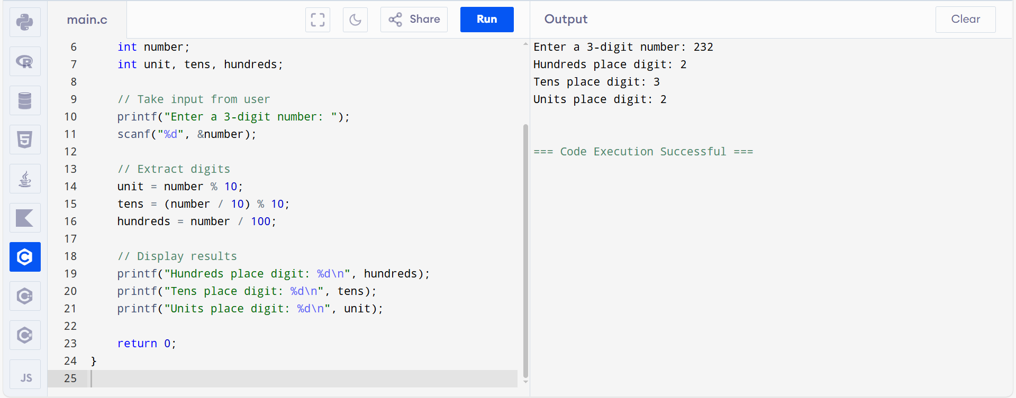
TASK # 05:
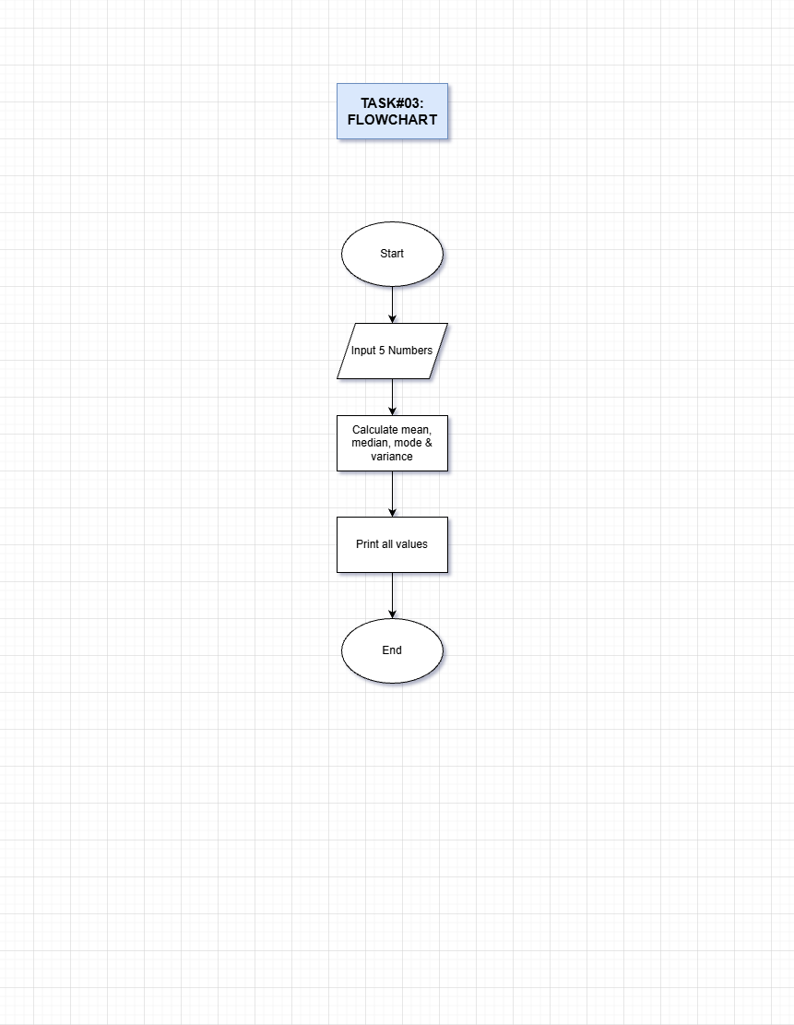
Take any five numbers from the user and find out mean, median, mode and standard deviation?
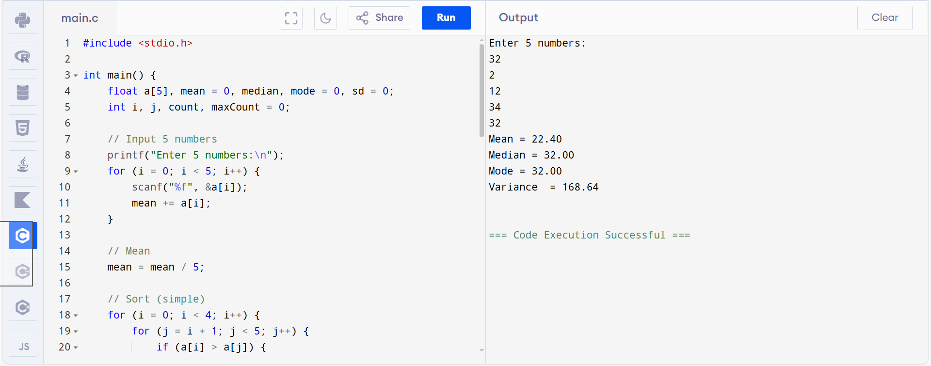

TASK # 06:
Take three points from the user (x1,y1), (x2,y2) and (x3, y3). Figure out whether these three points constitute a right-angle triangle?

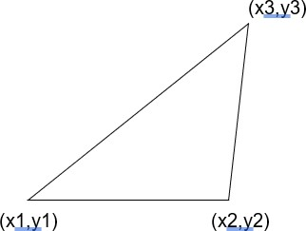

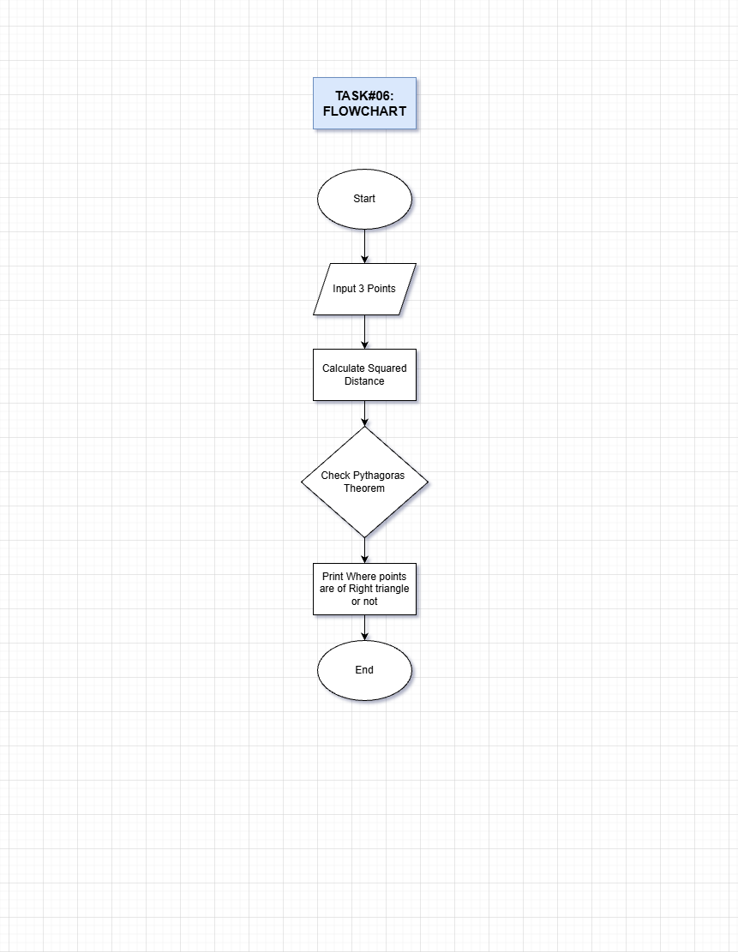
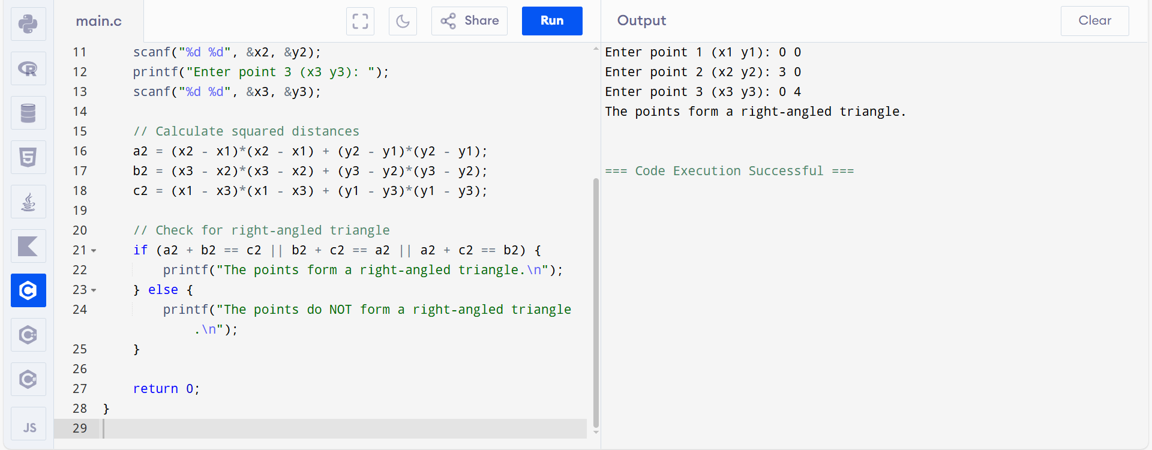
TASK # 07:
Imagine you are playing a grid (4x4) game where the player can move in four directions Up, Down, Right and Left. Take the initial position of the player from the user e.g. (1,2) and position of the obstacle e.g. (1,3). Now take the direction in which the player will move. Figure out whether it will collide with an obstacle or not? You need to check the boundary conditions.

(1,1) |  |  | (4,1)
(1,4) |  |  | (4,4)

Flow Chart: 15 minutes Coding: 25 minutes
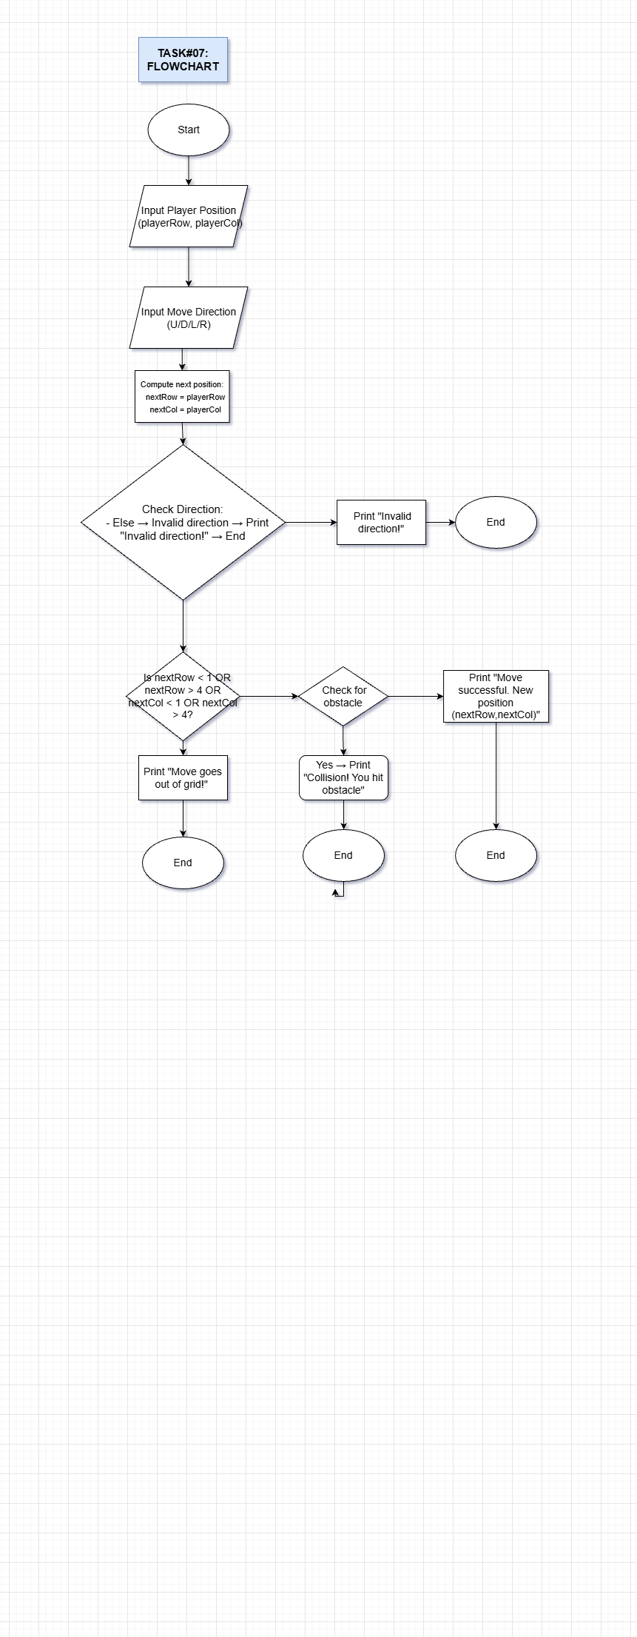


TASK # 08:
Bit Operations
For this task, you will complete bit_ops.c, available in the attached zip files folder. By implementing the bit manipulation functions get_bit, set_bit, and flip_bit (shown below). You may ONLY use bitwise operations such as and (&), or (|), xor (^), not (~), left shifts (<>). You may not use any for/while loops or conditional statements. You also may not use modulo (%), division, addition, subtraction, or multiplication for this question.
Finish implementing get_bit, set_bit, and flip_bit.
Once you complete these functions, you can compile and run your code using the following commands:
Gcc bit_ops.c test_bit_ops.c -o bit_ops
./bit_ops
This will print out the results of the tests. Make sure that you do not use any of the forbidden operations before running the code.

